**Jainish Sakhidas**

**TE3 – 65**

**Batch D**

**Subject: CN**

**Experiment 9**

**Aim:**

To configure Linux FTP server using VSFTPD.   
1. Set up anonymous access of FTP server.   
2. Enable individual logins and add FTP users with Read- only access.   
3. Transfer Files.

**Installing the package: vsftpd**

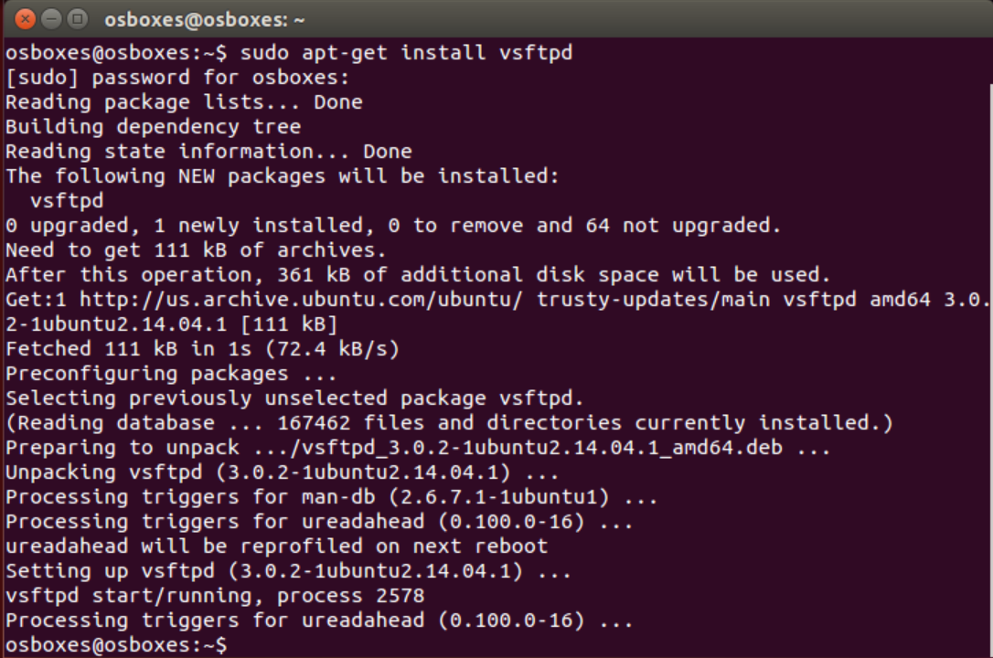

**Changing directory towards etc folder and to edit the vsftpd config file**



**Making the anonymous_enable from NO → YES**

**Commenting out the line local_enable**

**Uncommenting out the line write_enable**

**Saving the changes by → ctrl+O and hitting enter**

**Exiting by → ctrl+X**

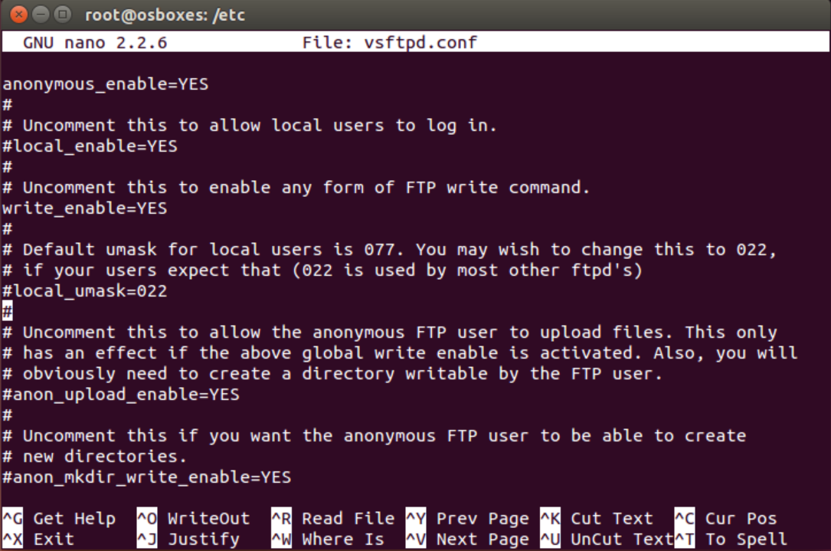

**Restarting the vsftpd service → service vsftpd restart & Using netstat to check the working of ftp protocol service**

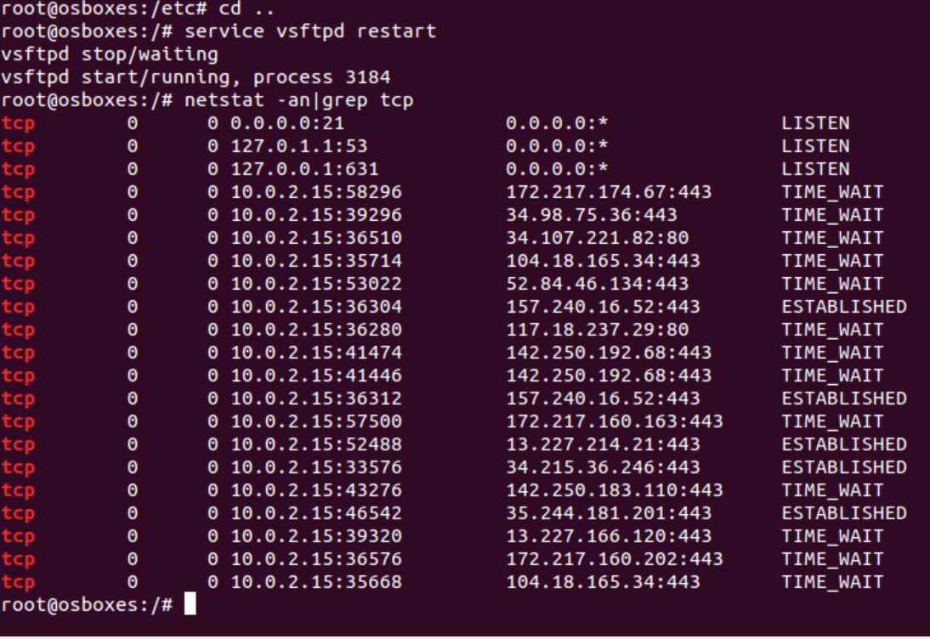

**Using ifconfig to get the IP address of the ubuntu system**

**My IP address is: 127.0.0.1**

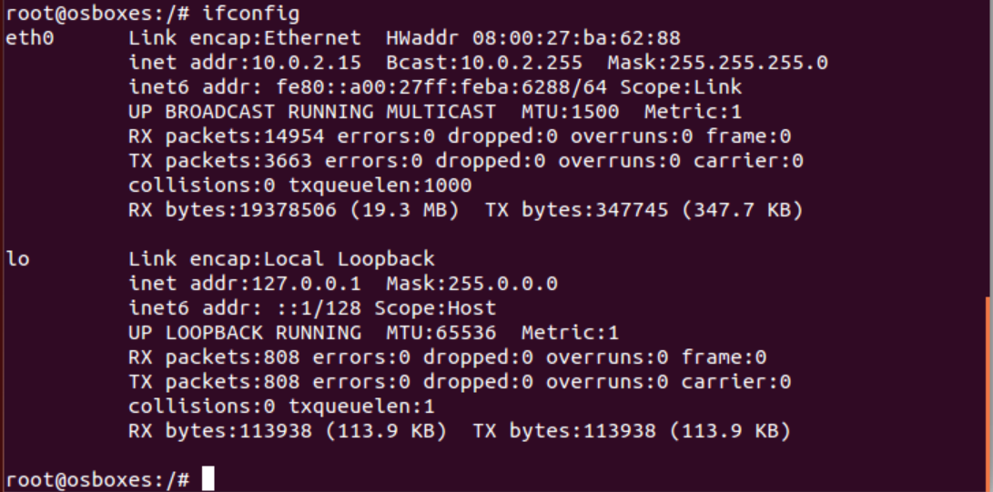

**Connecting my ip address with ftp and login as anonymous**

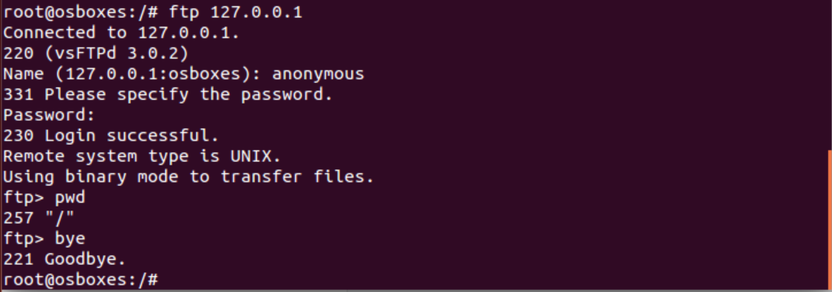

**Making the config file as it is**

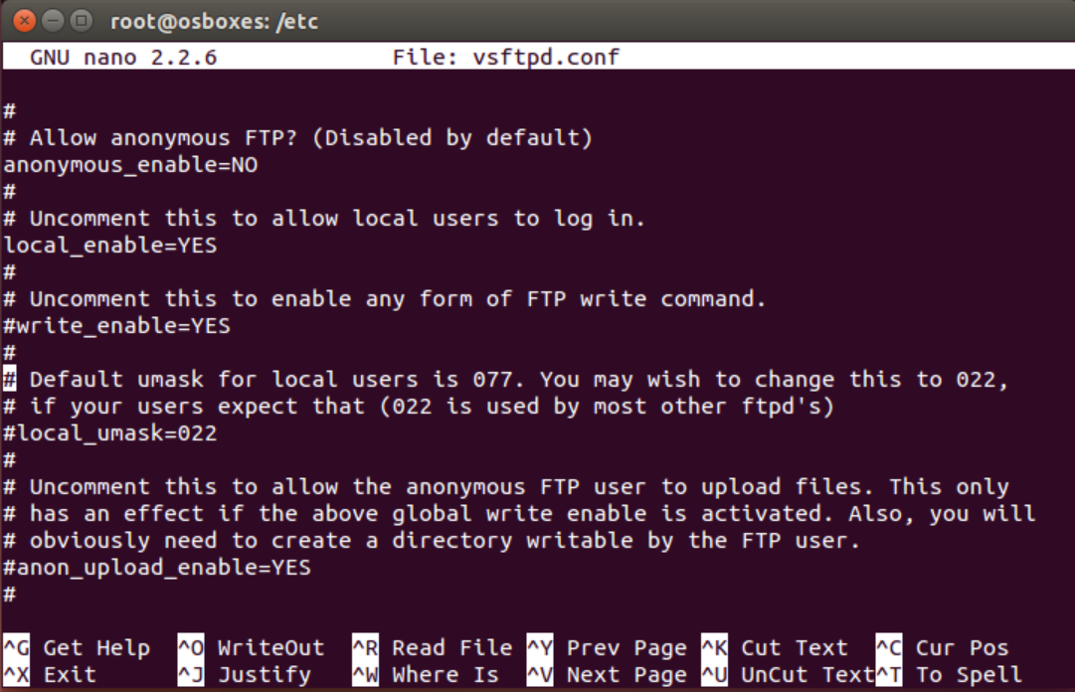

**Now, adding a user**

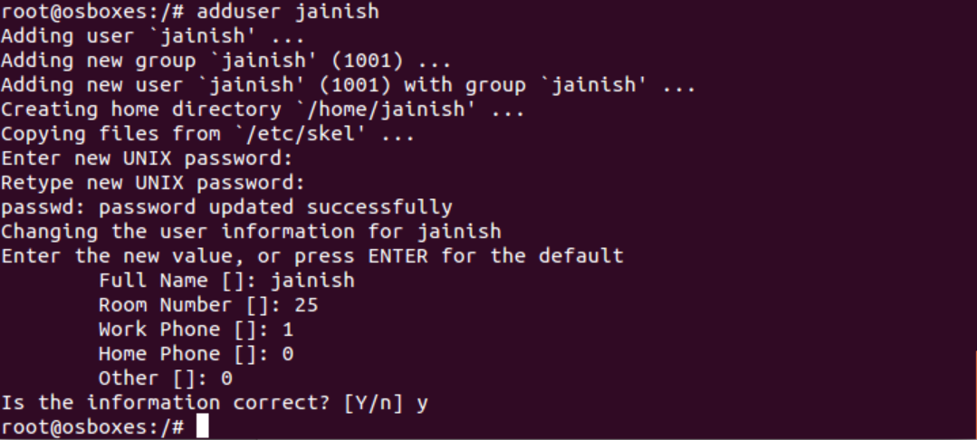

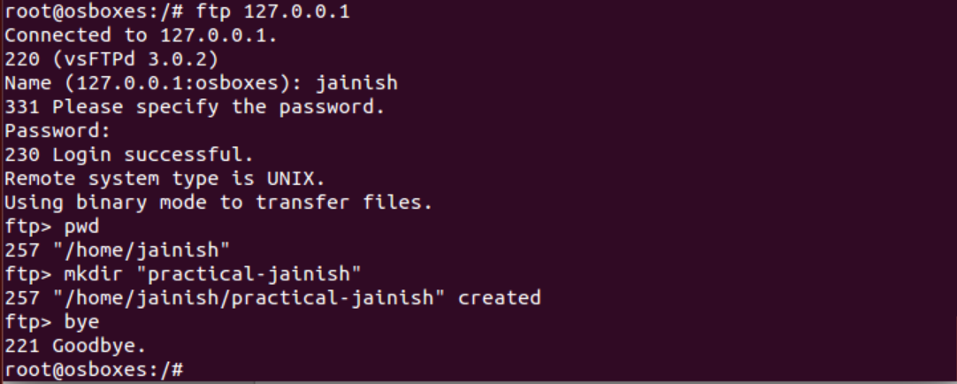

**User jainish has been added successfully**

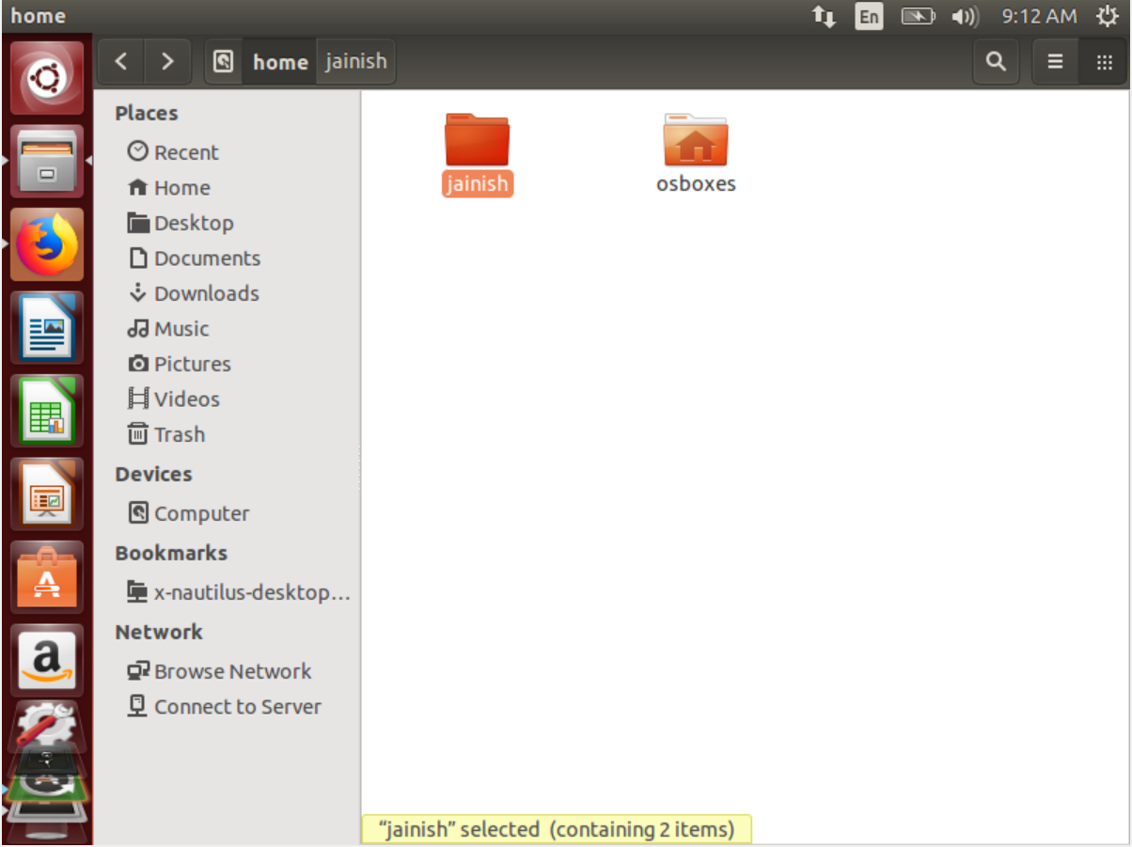

**A directory is successfully created under jainish**

